THEORY

1.What does TCL stand for?
TCL (Transaction Control Language) is a category of SQL commands used to manage database transactions using commands such as COMMIT, ROLLBACK, and SAVEPOINT.

2.Name the TCL commands?
The TCL commands are COMMIT, ROLLBACK, SAVEPOINT, ROLLBACK TO SAVEPOINT, and SET TRANSACTION. They are used to control and manage database transactions.

3.What is the purpose of COMMIT?
COMMIT is a TCL command that permanently saves all changes made during the current transaction to the database.
4.What is the difference between COMMIT and ROLLBACK?
COMMIT permanently saves the changes made in a transaction, whereas ROLLBACK cancels the uncommitted changes and restores the database to its previous state.
5.What does SAVEPOINT do?
SAVEPOINT creates a checkpoint in a transaction so you can roll back to that point without undoing the entire transaction.
6.What does DCL stand for?
DCL (Data Control Language) is a category of SQL commands used to control user access and permissions in a database using GRANT and REVOKE.
7.Name the DCL commands?
The DCL commands are GRANT and REVOKE, which are used to grant and remove user permissions in a database.
GRANT SELECT, INSERT
ON employee
TO user1;
REVOKE INSERT
ON employee
FROM user1;

8.What is the purpose of GRANT?
GRANT is a DCL command used to give users or roles specific permissions on database objects
9.What is the purpose of REVOKE?
REVOKE is a DCL command used to remove previously granted permissions or privileges from a user or role.
10.Can we rollback after COMMIT? Explain ?
No. After a COMMIT, the changes are permanently saved, so they cannot be undone using ROLLBACK.

SETUP
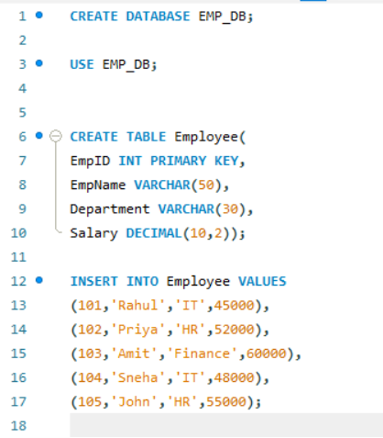

Increase Rahul's salary by ₹5000. Do not commit immediately. Verify the result. Rollback the transaction. What is Rahul's final salary?
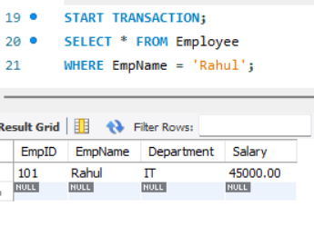

Increase every employee's salary by 10%. Commit the transaction. Verify the result.
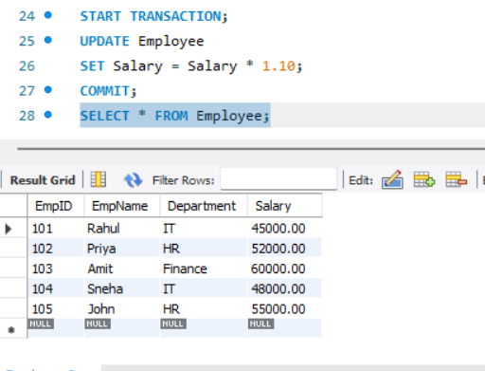

Increase Rahul's salary by ₹3000. Create SAVEPOINT sp1. Increase Priya's salary by ₹5000. Rollback to sp1. Which employee's salary is rolled back?

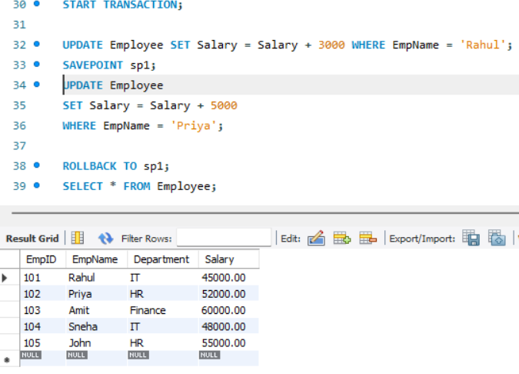

DELETE HR employees. Rollback. How many HR employees remain?
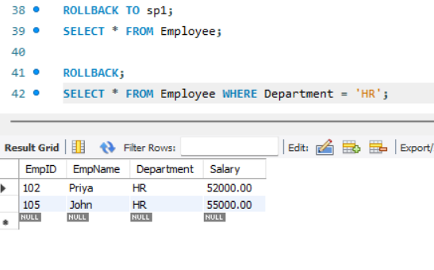
DELETE Finance employees. COMMIT. Then ROLLBACK. Will the Finance employee return? Explain
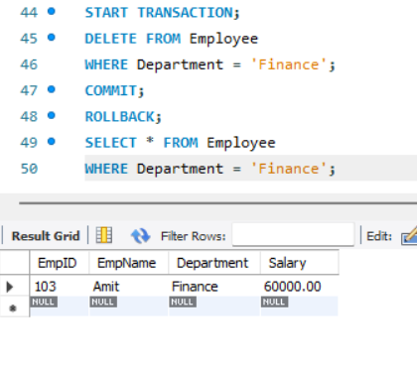

DCL

Write a query to GRANT SELECT on Employee to student1.
GRANT SELECT ON Employee TO student1;

Write a query to GRANT INSERT on Employee to student1.
GRANT INSERT ON Employee TO student1;

Write a query to GRANT UPDATE on Employee to student1.
GRANT UPDATE ON Employee TO student1;

Write a query to REVOKE INSERT from student1
REVOKE INSERT ON Employee FROM student1;

Write a query to REVOKE ALL permissions from student1
REVOKE ALL PRIVILEGES ON Employee FROM student1;

Scenario Based
A cashier accidentally updates 500 customer records before commit. Which TCL command should be used?
START TRANSACTION;

UPDATE Customer
SET Balance = Balance + 1000;

-- Mistake detected

ROLLBACK;

Salary changes are verified and should become permanent. Which command should be used?

START TRANSACTION;

UPDATE Employee
SET Salary = Salary + 5000
WHERE Department = 'IT';

COMMIT;

Undo only the last set of changes without affecting earlier updates. Which command should be used?
START TRANSACTION;
UPDATE Employee
SET Salary = Salary + 3000
WHERE EmpID = 101;
SAVEPOINT sp1;

UPDATE Employee
SET Salary = Salary + 5000
WHERE EmpID = 102;

ROLLBACK TO sp1;

A new employee should only view employee records. Which DCL command will you use?

GRANT SELECT
ON Employee
TO new_employee;

A user should no longer have permission to delete records. Which DCL command will you use?
REVOKE DELETE ON Employee FROM user1;

Output Prediction

START TRANSACTION;
UPDATE Employee SET Salary=Salary+5000 WHERE EmpID=101;
ROLLBACK;
SELECT Salary FROM Employee WHERE EmpID=101;

Will the updated or original salary be displayed?

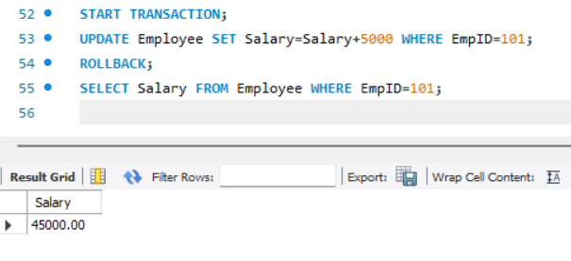

START TRANSACTION;
UPDATE Employee SET Salary=Salary+5000 WHERE EmpID=101; COMMIT; ROLLBACK;
Is the salary restored? Why?
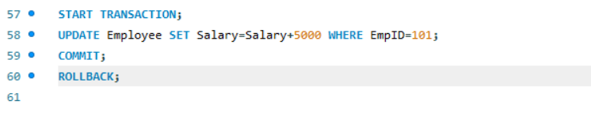
No. After COMMIT, the salary change is permanently saved, so ROLLBACK cannot restore the original salary.

Which employee receives the salary increment?
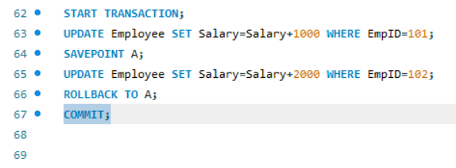
Only Employee 101 receives the salary increment because ROLLBACK TO A undoes the changes made after the savepoint, and COMMIT saves the remaining changes.

Final questions
Increase all IT salaries by 15%
UPDATE Employee – Updates the Employee table.
SET Salary = Salary * 1.15 – Increases the salary by 15%.
WHERE Department = 'IT' – Applies the increase only to employees in the IT department.

Create a SAVEPOINT.
SAVEPOINT sp1;

Increase all HR salaries by ₹2,000.
UPDATE Employee – Updates the Employee table.
SET Salary = Salary + 2000 – Increases the salary by ₹2,000.
WHERE Department = 'HR' – Applies the increase only to employees in the HR department.

Rollback only the HR update.
ROLLBACK TO sp1;

Commit remaining changes.
Use the COMMIT command to permanently save the remaining changes after rolling back the HR update.

Grant SELECT and UPDATE to student1.
GRANT SELECT, UPDATE ON Employee TO student1;

Revoke only UPDATE from student1.
REVOKE UPDATE ON Employee FROM student1;

